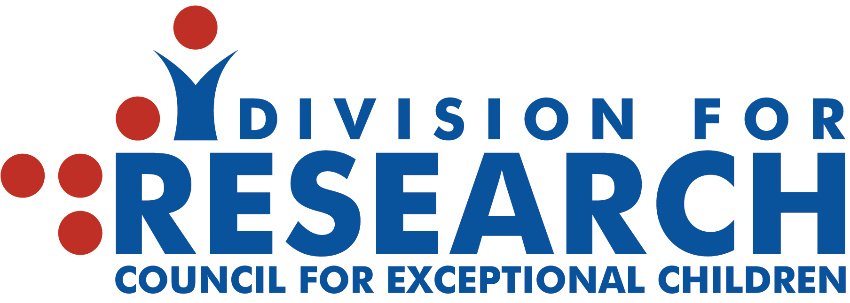

Call for Nominations
2021-2022 CEC-DR Doctoral Student Scholars
Division for Research, Council for Exceptional Children

DUE DATE: SEPTEMBER 30, 2021

Directions/Nomination Form below and at www.cecdr.org

The Division for Research invites nominations for outstanding doctoral student scholars to participate in the 2021-2022 Doctoral Seminars in Special Education Research. Selected student researchers will participate with peers in generative discussions and professional development led by distinguished researchers recognized for making outstanding scientific contributions in special education. Three virtual seminars and on-line forums will be held during this coming academic year along with a colloquium that brings students and researchers together in a session dedicated to graduate student development at the 2022 CEC convention in Orlando, FL.

Nominees
Nominees should be outstanding doctoral students in special education seeking careers in research. Nominees must have substantially completed their courses and be in the process of formulating a dissertation proposal or conducting dissertation research. Invitations will be issued to 10 doctoral students, with competition based on the judged quality of the student's research and capacity to gain from and contribute to the seminars.

Nomination Process
Students will be chosen to participate in the doctoral seminar series through a rigorous selection process:

- Advanced doctoral students are nominated as CEC-DR Doctoral Student Scholars by a faculty member who can attest to the quality of their scholarship.

- Students submit an abstract and a detailed summary research proposal that outlines relevant features of their study.

- The proposals are blind reviewed by members of the DR-DSS planning committee.

The Nomination Packet
Directions for Students: Email the following 2 items in separate attachments to your nominating faculty member.

- Abstract of student's research project that is no more than 120 words.

- Two-page summary statement of student’s proposed research. The summary statement should be no more than two (2) single-spaced pages and should outline the problem you are pursuing or plan to pursue in your research, its intended contribution to theory and practice, specific research questions, and study procedures. Follow APA style throughout your submission. Use 12-point Times New Roman font, single spacing and 1-inch margins all around in your document and save as a Word document. Up to 5 additional pages for References, Tables and Figures may be included and will not count against the 2-page limit. References should include works cited only. Remove all information about the nominee's name and institution. The statement is forwarded to DR-DSS reviewers during the selection process.

Directions for Faculty Nominators:

- Please compile the nomination packet (letter of nomination, abstract of student research, and statement of proposed research) for the nominee.

- Your letter of nomination should be no more than 2 pages (12 point Times New Roman font, single spaced, 1-inch margins). Please explain why this student was selected, with special reference to academic performance and prospects for a career in research. (You might consider informing the committee about why you think this student would benefit from participating; what the student has to share with peers from other universities; or the research projects, publications, or other scholarly activities the student has engaged in during doctoral study.)

- Complete the Nomination Form:

https://docs.google.com/forms/d/e/1FAIpQLSf573QDOs_ZaL66vMw8cnhBO7X7Su9poCTheFDQ-uEKkmOMOA/viewform?usp=sf_link

Upload all three (3) items (i.e., letter of nomination, abstract of student research, statement of proposed research) in the upload portal provided in the last item of the form to be received no later than September 30, 2021. Please save all items in a Word format to facilitate the handling for reviewers.

- Nominators are cordially invited to attend the colloquium at CEC, usually scheduled on Friday afternoon and followed by the DR business meeting and reception.

We expect to extend invitations to 10 doctoral student scholars by the end of October. All nominating faculty members will be notified of the outcome for their students at that time.

Please submit nomination packets electronically using the form above. For questions, contact Dr. Jean Crockett, University of Florida, jcrockett@coe.ufl.edu; Dr. Mary Theresa Kiely, Queens College, City University of New York, mary.theresa.kiely@qc.cuny.edu; or Dr. Kristen Merrill O’Brien, George Mason University, kmerril2@gmu.edu.

NOMINATION PACKETS MUST BE SUBMITTED ELECTRONICALLY THROUGH THE NOMINATION FORM (see link above)
NO LATER THAN SEPTEMBER 30, 2021

